Project Design Phase-II
Technology Stack (Architecture & Stack)

Date | 31 January 3035
Team ID | LTVIP2026TMIDS65742
Project Name | FlightFinder: Navigating Your Air Travel Options
Maximum Marks | 4 Marks

Technical Architecture:
The Deliverable shall include the architectural diagram as below and the information as per the table1 & table 2
Example: Order processing during pandemics for offline mode
Reference: https://developer.ibm.com/patterns/ai-powered-backend-system-for-order-processing-during-pandemics/
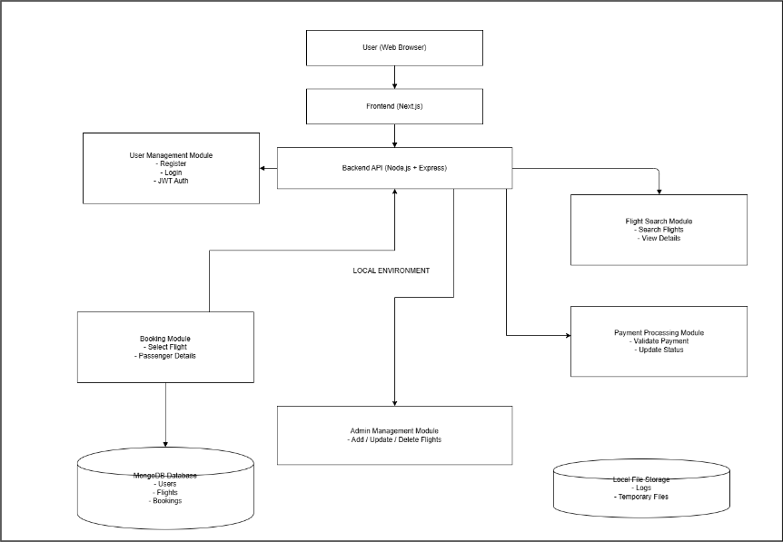
The Flight Booking Application follows a 3-tier architecture consisting of the Presentation Layer, Application Layer, and Data Layer. The frontend, built using Next.js, handles user interaction and communicates with the backend via REST APIs. The backend, developed using Node.js and Express.js, manages business logic including authentication, flight search, booking, and payment processing. Data is stored in MongoDB, which maintains user, flight, and booking information.

Table-1 : Components & Technologies:
S.No | Component | Description | Technology
1 | User Interface | Web interface for searching and booking flights | Next.js, HTML, CSS, JavaScript
2 | Application Logic-1 | User authentication and session handling | Node.js, Express.js
3 | Application Logic-2 | Flight search and booking logic | Express.js
4 | Database | Stores users, flights, bookings | MongoDB
5 | Cloud Database | Cloud-hosted database (optional) | MongoDB Atlas
6 | File Storage | Stores temporary booking logs (if needed) | Local Filesystem
7 | External API-1 | Payment gateway integration | Razorpay API / Stripe API
9 | Infrastructure (Server / Cloud) | Deployment of frontend & backend | Localhost / Vercel / Render

Table-2: Application Characteristics:
S.No | Characteristics | Description | Technology
1 | Open-Source Frameworks | Frameworks used in development | Next.js, Express.js
2 | Security Implementations | Password encryption and session handling | bcrypt, JWT Authentication
3 | Scalable Architecture | 3-Tier separation of UI, Backend & DB | REST API Architecture
4 | Availability | System accessible via web browser | Cloud Hosting (Vercel / Render)
5 | Performance | Optimized queries and fast response | MongoDB Indexing

References:
https://c4model.com/
https://developer.ibm.com/patterns/online-order-processing-system-during-pandemic/
https://www.ibm.com/cloud/architecture
https://aws.amazon.com/architecture
https://medium.com/the-internal-startup/how-to-draw-useful-technical-architecture-diagrams-2d20c9fda90d

